**DATA ANALYST PROJECT**

Stock Market Live Insights

Data File:

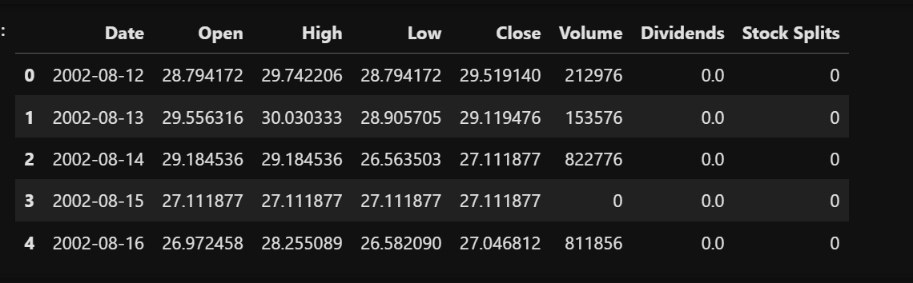

Heatmap of correlation of features with the target variable

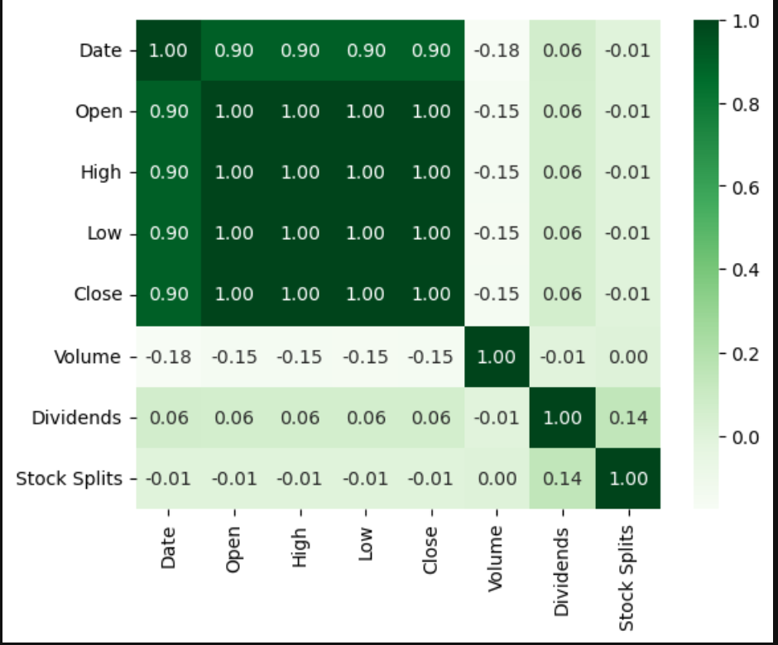

Plotting Close price over time

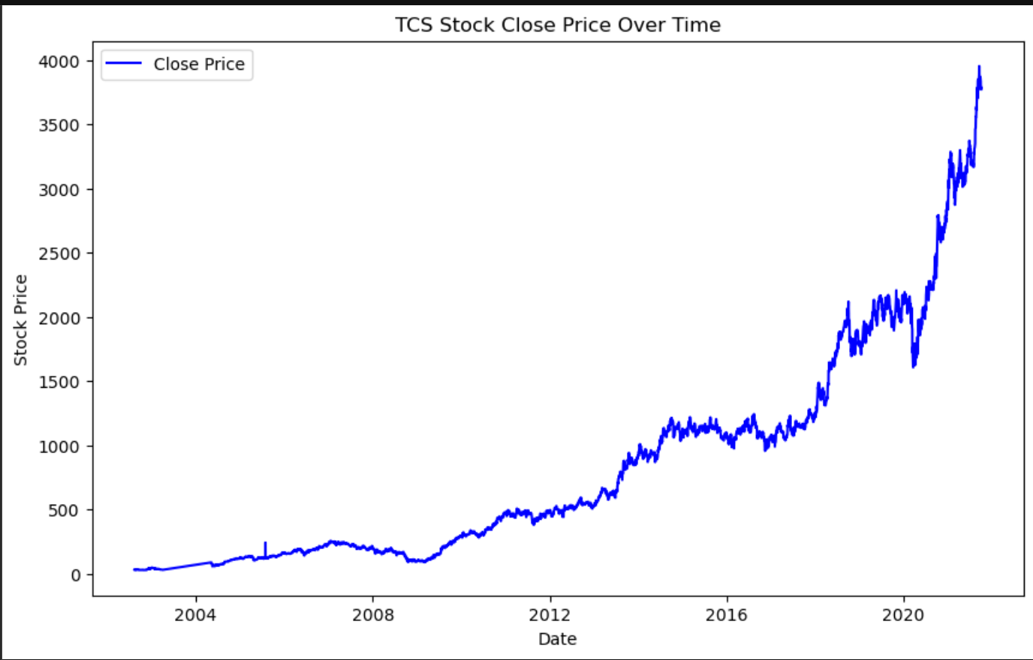

Plotting Open price over time

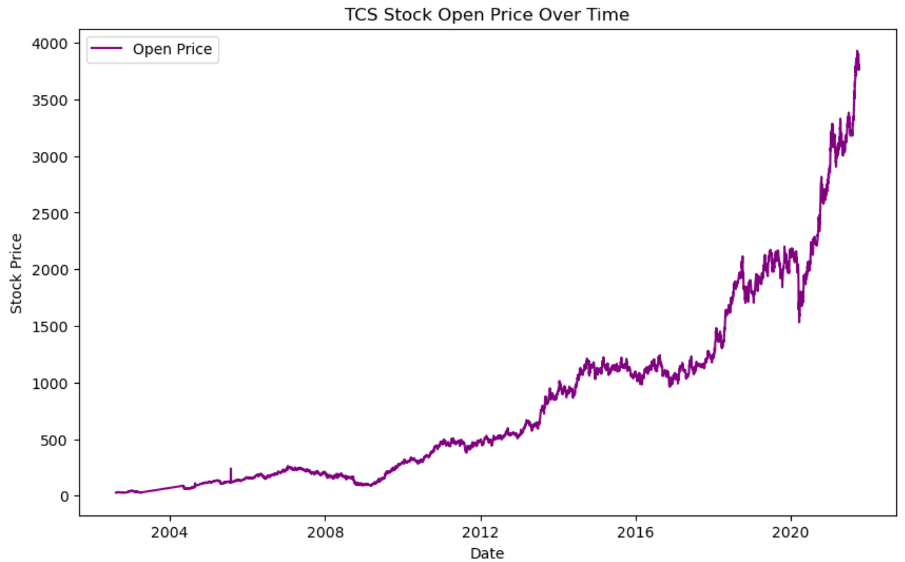

Volume, Dividends, Stock Splits

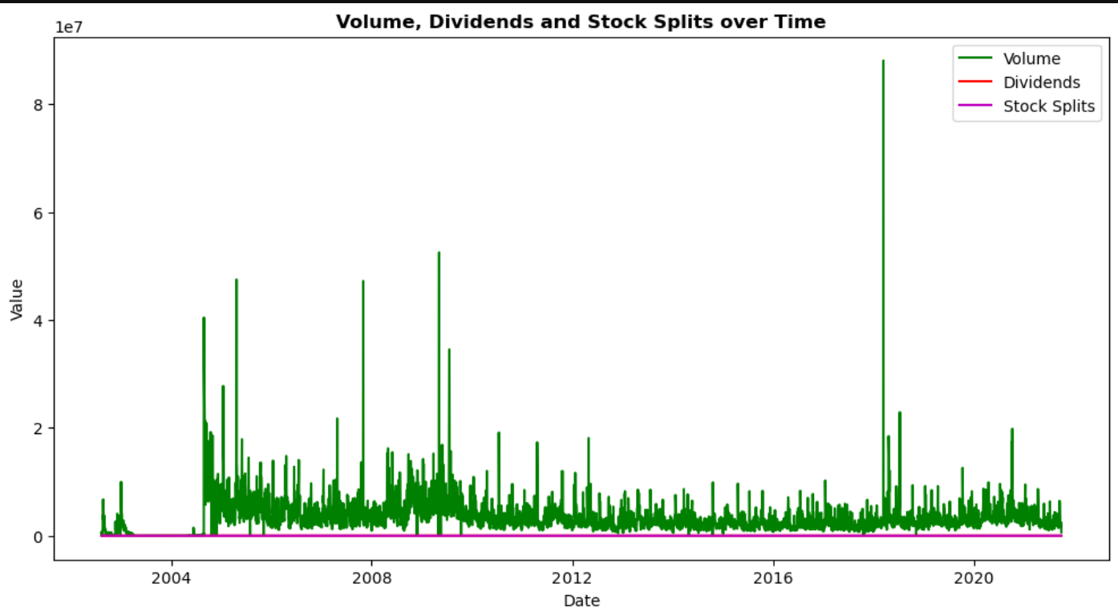

Close vs Volume

Dividends and Stock Splits

Stock Splits Vs Close Price

Moving Average Crossover Strategy

DAILY PRICE CHANGE

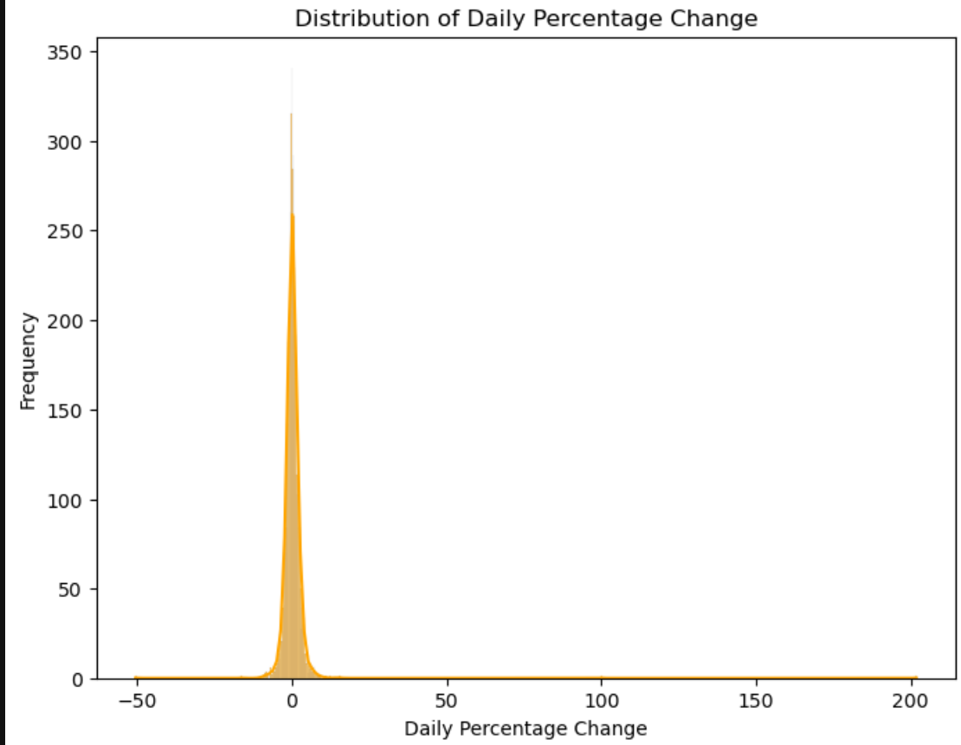

Using the LSTM neural networks we predict the actual vs predicted close price of the specific stock

